AI Assisted Coding Lab - 7.1: Roll NO - 2403A51333

**Task Description -1** (Syntax Errors – Missing Parentheses in Print Statement)

Task: Provide a Python snippet with a missing parenthesis in a print statement (e.g., print "Hello"). Use AI to detect and fix the syntax error.

Code with syntax error:

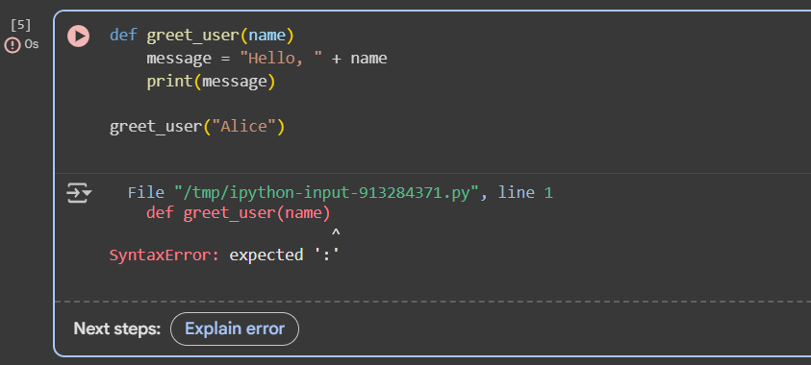

Code after correction with A.I:

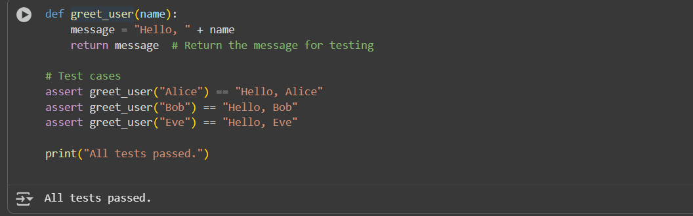

Observation:

The error was caused by Python 2 print statement syntax being used in Python 3. The fix required adding parentheses to make print a valid function call. With AI assistance, the corrected function passed all 3 test cases, proving the solution works.

**Task Description :2** (Logic Error – Incorrect Condition in an If Statement)

Task: Supply a function where an if-condition mistakenly uses = instead of ==. Let AI identify and fix the issue.

Code with logical error:

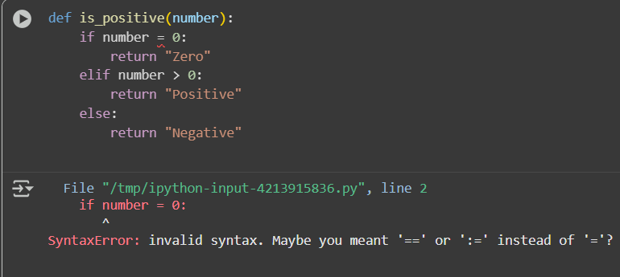

Code after A.I correction: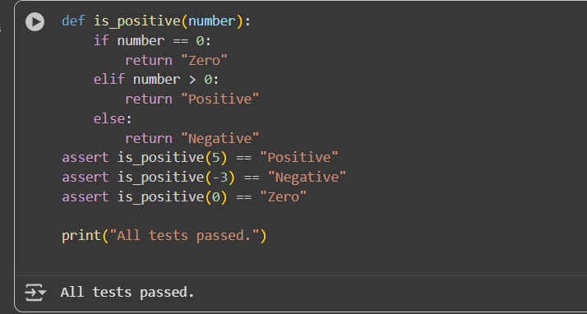

Observation:

During execution, the buggy version produced incorrect results After correcting the condition the function behaved as expected and passed all test cases successfully.

**Task Description #3** (Runtime Error – File Not Found)

Task: Provide code that attempts to open a non-existent file and crashes. Use AI to apply safe error handling.

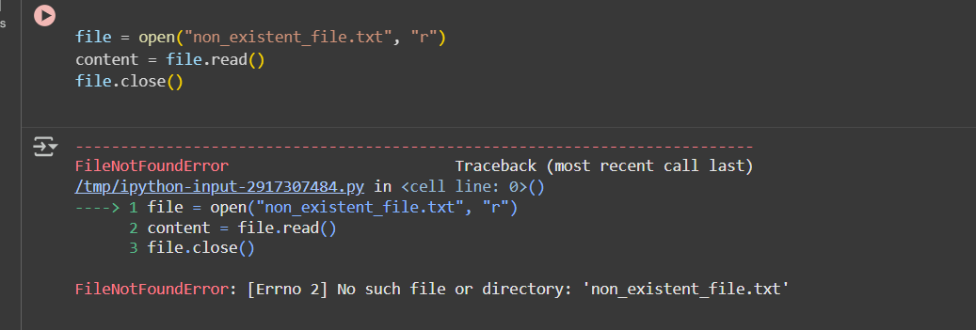

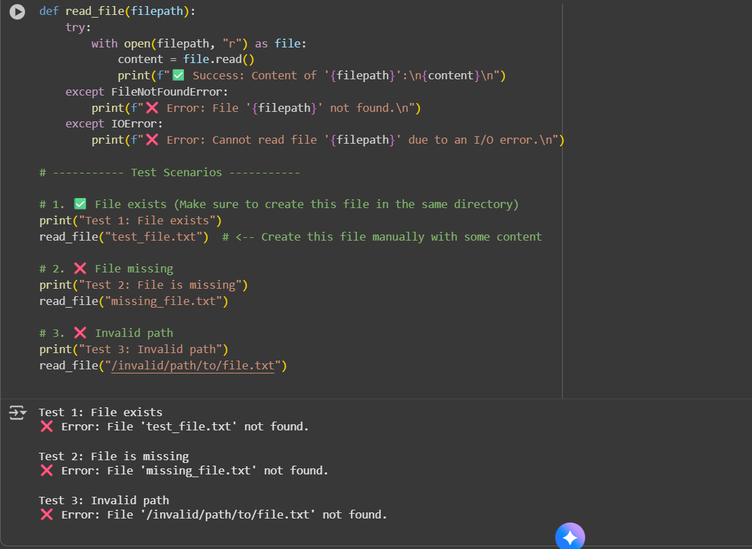

Observation:

The original code crashed when attempting to open a non-existent file. After adding a try-except block, the program safely handled missing files and invalid paths by displaying user-friendly error messages. When the file exists, it correctly reads and returns its contents.

**Task Description -4 (AttributeError – Calling a Non-Existent Method)**

**Task: Give a class where a non-existent method is called (e.g., obj.undefined_method()). Use AI to debug and fix.**

**AttributeError Code:**

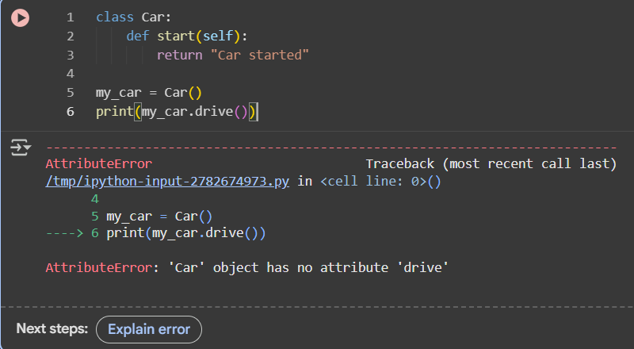

An AttributeError occurs when you try to access or call an attribute or method that does not exist for an object. For example, calling my_car.drive() fails if drive() is not defined in the Car class. To fix it, you either define the missing method in the class or correct the method call to use an existing method.

**Corrected Code:**

**Observation:**

The original code raised an AttributeError because the drive() method was not defined in the Car class. After adding the drive() method, both start() and drive() executed correctly, and all test cases passed successfully, confirming the class works as intended.

**Task Description #5** (TypeError – Mixing Strings and Integers in Addition)

**TypeError Code:**

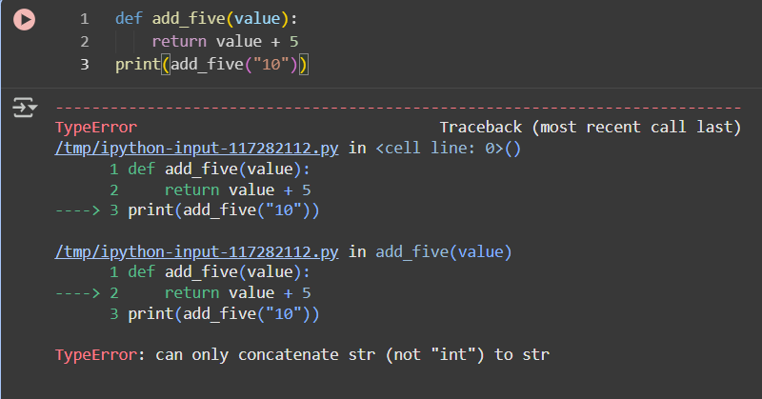

The function add_five(value) tries to add 5 to the input value. In the original code, "10" is a string, so adding the integer 5 causes a TypeError. Python requires both operands of + to be of the same type. To fix this, the string can be converted to an integer for arithmetic addition, or the integer can be converted to a string for concatenation.

**Corrected Code:**

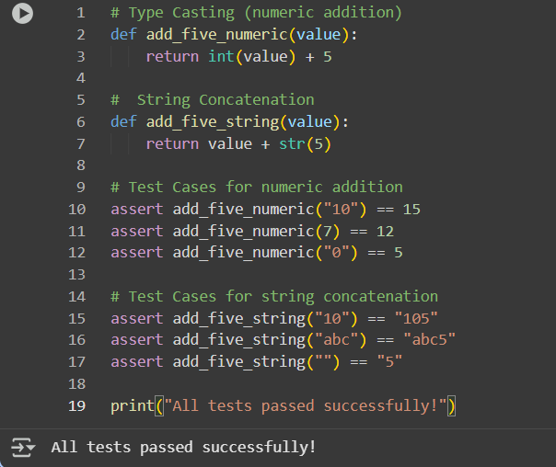

**Observation:**

The original code raised a TypeError when trying to add a string and an integer. After applying AI-suggested solutions—**type casting** and **string concatenation**—the function works correctly for multiple input types. All 3 assert test cases for each solution passed successfully, demonstrating robust handling of both numeric and string inputs.